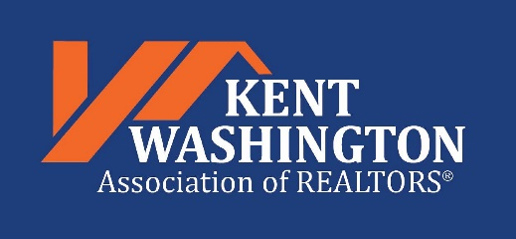
“The Ocean State’s Trusted Voice in Real Estate”

LOCKBOX ORDER FORM
I would like to purchase ___ Lockboxes @ $50 each, as a part of my 2021 KWAOR member benefits. I understand that payment will be due upon pickup at the KWAOR office. I also understand that I (and my team members, if any) must activate a SentriLock account and download the SentriKey application to my phone or tablet in order to use the lockboxes I purchase. The monthly app fee is free to all KWAOR REALTOR® member users for 2021, a savings of over $8 per month.

Payment can be made via check or credit card (American Express, Discover, MasterCard, or VISA).
Please call ahead to allow proper setup of your lockboxes (and team, if needed). Pickup is available Monday-Friday, 10 AM to 4 PM. Please call Carol Drewes at (401) 885-9300 before coming in, so that we can have your lockboxes ready when you arrive.
PLEASE PRINT

KWAOR MEMBER NAME: ______________________________________________________________

FIRM:_______________________________________________________________________________
OFFICE ADDRESS____________________________________________________________________

CITY____________________________________________STATE_____ZIP______________________
CELL PHONE_____________________

Note: Lockboxes can be shared by teams. If you plan to set your boxes up for team use, please use the REQUEST FOR SENTRILOCK LOCKBOX TEAM SETUP form to identify your team and authorize team permissions.

Need more information? See the SentriLock tab on our website (www.kwaor.realtor), or call us!
You may request activation of your SentriKey app, OR schedule an in-office demo of the SentriLock lockbox and SentriKey mobile application by a KWAOR member by contacting Carol Drewes at (401) 885-9300.
Please email your completed form to the KWAOR office to carol@kwaor.realtor. Orders will be confirmed via email.

