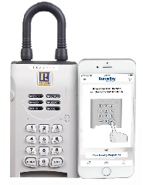
2026 SentriKey App
User Authorization Form
☐ YES, I choose to participate in the KWAOR SentriKey App User Program for a fee of $115 annually. Fees will be prorated monthly.

☐ YES, I want up to 3 SentriLock lockboxes at no charge. # of lockboxes __________

Complete the following information to activate your SentriKey account. Payment can be made by credit card or check. Checks can be made payable to KWAOR.

Name:

Cell Phone:

Firm:

Credit Card #:
Billing Street Address:

Town/City State Zip Code
Expiration Date: Code:

Signature:

Email completed form to Kathleen@kwaor.realtor or mail to
KWAOR, 2240 South County Tr. Suite #3, East Greenwich, RI 02818

Need more information? Contact Linda Arcouette at Linda@kwaor.realtor or call (401) 885-9300

